**TASK 5**

**CUCUMBER WITH JENKINS**

**Step definition**

**package** StepDefinitions;

**import** org.openqa.selenium.By;

**import** org.openqa.selenium.WebDriver;

**import** org.openqa.selenium.chrome.ChromeDriver;

**import** org.openqa.selenium.interactions.Actions;

**import** io.cucumber.java.en.Given;

**import** io.cucumber.java.en.Then;

**import** io.cucumber.java.en.When;

**public** **class** StepDefinition {

WebDriver driver =**null**;

@Given("the user opens the browser")

**public** **void** the_user_opens_the_browser_1() {

System.*setProperty*("webdriver.chrome.driver","C:\\Users\\user\\Downloads\\chromedriver_win32 (1)\\chromedriver.exe" );

driver = **new** ChromeDriver();

driver.manage().window().maximize();

}

@When("the user navigates to urban ladder")

**public** **void** the_user_navigates_to_urban_ladder1 () {

driver.get("https://www.urbanladder.com/");

}

@Then("search living section_1")

**public** **void** search_living_section_1() **throws** InterruptedException {

driver.findElement(By.*id*("search")).getTagName();

driver.manage().window().maximize();

driver.navigate().to("https://www.urbanladder.com/living-room-furniture?src=g_breadcrumb");

Thread.*sleep*(6000);

driver.findElement(By.*xpath*("//*[@id=\"authentication_popup\"]/div[1]/div/div[2]/a[1]")).click();

System.***out***.println("Pop-up Closed");

Thread.*sleep*(2000);

driver.findElement(By.*xpath*("//*[@id=\"topnav_wrapper\"]/ul/li[2]/span")).click();

System.***out***.println("Clicking on living");

Thread.*sleep*(2000);

driver.findElement(By.*xpath*("//*[@id=\"topnav_wrapper\"]/ul/li[2]/div/div/ul/li[3]/ul/li[6]/a/span")).click();

Thread.*sleep*(2000);

System.***out***.println("Clicking on gaming chairs");

driver.findElement(By.*xpath*("//*[@id=\"filters_availability_In_Stock_Only\"]")).click();

System.***out***.println("Checkboxing now");

Thread.*sleep*(2000);

Thread.*sleep*(2000);

driver.findElement(By.*xpath*("//*[@id=\"filters-form\"]/div[1]/div/div/ul/li/div[1]")).click();

Thread.*sleep*(2000);

driver.findElement(By.*xpath*("//*[@id=\"price_limit_8717-9373\"]")).click();

Thread.*sleep*(2000);

System.***out***.println("Clicking radio button");

driver.findElement(By.*xpath*("//*[@id=\"filters-form\"]/div[1]/div/div/ul/li/div[2]/div/div/ul/li[1]/div/div[1]/span[2]")).click();

Thread.*sleep*(2000);

System.***out***.println("Clearing filter");

driver.findElement(By.*xpath*("//*[@id=\"price_limit_9374-10029\"]")).click();

Thread.*sleep*(2000);

System.***out***.println("Changed the price limit filter");

Actions actions = **new** Actions(driver);

actions.moveToElement(driver.findElement(By.*xpath*("//*[@id=\"content\"]/div[4]/ul/li"))).perform();

System.***out***.println("Cursor hovered over to price");

Thread.*sleep*(2000);

System.***out***.println("Window closed");

driver.close();

}

@Given("the user opens the browser2")

**public** **void** opens_the_browser_2() {

System.*setProperty*("webdriver.chrome.driver","C:\\Users\\user\\Downloads\\chromedriver_win32 (1)\\chromedriver.exe" );

driver = **new** ChromeDriver();

driver.manage().window().maximize();

}

@When("the user navigates to urban ladder2")

**public** **void** the_user_navigates_to_urban_ladder2() {

driver.get("https://www.urbanladder.com/");

}

@Then("selecting product in section_1")

**public** **void** selecting_product_in_section_1() **throws** InterruptedException {

driver.findElement(By.*id*("search")).getTagName();

driver.manage().window().maximize();

System.***out***.println("selecting the product");

driver.navigate().to("https://www.urbanladder.com/products/gerika-gaming-chair?sku=FVSTCH51OB30320&src=subcat");

Thread.*sleep*(6000);

driver.findElement(By.*xpath*("//*[@id=\"authentication_popup\"]/div[1]/div/div[2]/a[1]")).click();

System.***out***.println("Pop-up Closed");

driver.findElement(By.*xpath*("//*[@id=\"product-thumbnails\"]/li[3]/a/img")).click();

Thread.*sleep*(2000);

System.***out***.println("change the view");

driver.findElement(By.*xpath*("//*[@id=\"add-to-cart-button\"]")).click();

Thread.*sleep*(2000);

System.***out***.println("add to cart");

driver.findElement(By.*xpath*("//*[@id=\"checkout-link\"]")).click();

Thread.*sleep*(2000);

System.***out***.println("checkout");

driver.findElement(By.*id*("order_email")).sendKeys("abc@gmail.com");

driver.findElement(By.*id*("order_ship_address_attributes_zipcode")).sendKeys("683580");

driver.findElement(By.*id*("order_ship_address_attributes_address1")).sendKeys("abcdefg");

driver.findElement(By.*id*("order_ship_address_attributes_firstname")).sendKeys("xxxxxx");

driver.findElement(By.*id*("order_ship_address_attributes_lastname")).sendKeys("yyyyyy");

driver.findElement(By.*id*("order_ship_address_attributes_phone")).sendKeys("xxxxxx");

driver.findElement(By.*id*("gstin")).sendKeys("gst123");

driver.findElement(By.*id*("address-form-submit")).click();

Thread.*sleep*(2000);

System.***out***.println("filling up the details");

System.***out***.println("Window closed");

driver.close();

}

@Given("the user opens the browser3")

**public** **void** opens_the_browse3() {

System.*setProperty*("webdriver.chrome.driver","C:\\Users\\user\\Downloads\\chromedriver_win32 (1)\\chromedriver.exe" );

driver = **new** ChromeDriver();

driver.manage().window().maximize();

}

@When("the user navigates to urban ladder3")

**public** **void** navigates_to_urban_ladder3() {

driver.get("https://www.urbanladder.com/");

}

@Then("selecting product in section3")

**public** **void** selecting_product_in_section_3() **throws** InterruptedException {

driver.findElement(By.*id*("search")).getTagName();

driver.manage().window().maximize();

System.***out***.println("selecting the product3");

driver.navigate().to("https://www.urbanladder.com/products/altura-coffee-table-with-nested-stools?sku=FNTBCF12TT10053&src=room");

Thread.*sleep*(6000);

driver.findElement(By.*xpath*("//*[@id=\"authentication_popup\"]/div[1]/div/div[2]/a[1]")).click();

System.***out***.println("Pop-up Closed");

driver.findElement(By.*xpath*("//*[@id=\"product-thumbnails\"]/li[5]/a/img")).click();

Thread.*sleep*(2000);

System.***out***.println("change the view");

driver.findElement(By.*xpath*("//*[@id=\"add-to-cart-button\"]")).click();

Thread.*sleep*(2000);

System.***out***.println("add to cart");

driver.findElement(By.*xpath*("//*[@id=\"checkout-link\"]")).click();

Thread.*sleep*(2000);

System.***out***.println("checkout");

driver.findElement(By.*id*("order_email")).sendKeys("abc@gmail.com");

driver.findElement(By.*id*("order_ship_address_attributes_zipcode")).sendKeys("683580");

driver.findElement(By.*id*("order_ship_address_attributes_address1")).sendKeys("abcdefg");

driver.findElement(By.*id*("order_ship_address_attributes_firstname")).sendKeys("xxxxxx");

driver.findElement(By.*id*("order_ship_address_attributes_lastname")).sendKeys("yyyyyy");

driver.findElement(By.*id*("order_ship_address_attributes_phone")).sendKeys("xxxxxx");

driver.findElement(By.*id*("gstin")).sendKeys("gst123");

driver.findElement(By.*id*("address-form-submit")).click();

System.***out***.println("Window closed");

driver.close();

}

@Given("the user opens the browser4")

**public** **void** opens_the_browse4() {

System.*setProperty*("webdriver.chrome.driver","C:\\Users\\user\\Downloads\\chromedriver_win32 (1)\\chromedriver.exe" );

driver = **new** ChromeDriver();

driver.manage().window().maximize();

}

@When("the user navigates to urban ladder4")

**public** **void** navigates_to_urban_ladder4() {

driver.get("https://www.urbanladder.com/");

}

@Then("selecting product in section4")

**public** **void** selecting_product_in_section_4() **throws** InterruptedException {

driver.findElement(By.*id*("search")).getTagName();

driver.manage().window().maximize();

System.***out***.println("selecting the product4");

driver.navigate().to("https://www.urbanladder.com/products/altura-coffee-table-with-nested-stools?sku=FNTBCF12TT10053&src=room");

Thread.*sleep*(6000);

driver.findElement(By.*xpath*("//*[@id=\"authentication_popup\"]/div[1]/div/div[2]/a[1]")).click();

System.***out***.println("Pop-up Closed");

driver.findElement(By.*xpath*("//*[@id=\"add-to-cart-button\"]")).click();

Thread.*sleep*(2000);

System.***out***.println("add to cart");

driver.findElement(By.*xpath*("//*[@id=\"checkout-link\"]")).click();

Thread.*sleep*(2000);

System.***out***.println("checkout");

driver.findElement(By.*id*("order_email")).sendKeys("abc@gmail.com");

driver.findElement(By.*id*("order_ship_address_attributes_zipcode")).sendKeys("683580");

driver.findElement(By.*id*("order_ship_address_attributes_address1")).sendKeys("abcdefg");

driver.findElement(By.*id*("order_ship_address_attributes_firstname")).sendKeys("xxxxxx");

driver.findElement(By.*id*("order_ship_address_attributes_lastname")).sendKeys("yyyyyy");

driver.findElement(By.*id*("order_ship_address_attributes_phone")).sendKeys("xxxxxx");

driver.findElement(By.*id*("gstin")).sendKeys("gst123");

driver.findElement(By.*id*("address-form-submit")).click();

System.***out***.println("Window closed");

driver.close();

}

}

**Feature File**

Feature: This test the urbanladder website

Scenario: Test the living section_1

Given the user opens the browser

When the user navigates to urban ladder

Then search living section_1

Scenario: Test the living section_2

Given the user opens the browser2

When the user navigates to urban ladder2

Then selecting product in section_1

Scenario: Test the living section_3

Given the user opens the browser3

When the user navigates to urban ladder3

Then selecting product in section3

Scenario: Test the living section_4

Given the user opens the browser4

When the user navigates to urban ladder4

Then selecting product in section4

**POM File**

<project xmlns=*"http://maven.apache.org/POM/4.0.0"* xmlns:xsi=*"http://www.w3.org/2001/XMLSchema-instance"* xsi:schemaLocation=*"http://maven.apache.org/POM/4.0.0 https://maven.apache.org/xsd/maven-4.0.0.xsd"*>

<modelVersion>4.0.0</modelVersion>

<groupId>Capstoneproject</groupId>

<artifactId>Capstoneproject</artifactId>

<version>0.0.1-SNAPSHOT</version>

<dependencies>

<dependency>

<groupId>org.seleniumhq.selenium</groupId>

<artifactId>selenium-java</artifactId>

<version>2.47.1</version>

</dependency>

<dependency>

<groupId>io.cucumber</groupId>

<artifactId>cucumber-java</artifactId>

<version>5.7.0</version>

</dependency>

<dependency>

<groupId>io.cucumber</groupId>

<artifactId>cucumber-junit</artifactId>

<version>5.7.0</version>

</dependency>

<dependency>

<groupId>junit</groupId>

<artifactId>junit</artifactId>

<version>4.13</version>

</dependency>

</dependencies>

|  |
| --- |
| <build> |
|  | <plugins> |
|  | <plugin> |
|  | <artifactId>maven-compiler-plugin</artifactId> |
|  | <version>3.3</version> |
|  | <configuration> |
|  | <source>1.8</source> |
|  | <target>1.8</target> |
|  | </configuration> |
|  | </plugin> |
|  | <plugin> |
|  | <groupId>org.apache.maven.plugins</groupId> |
|  | <artifactId>maven-surefire-plugin</artifactId> |
|  | <version>2.19.1</version> |
|  | <configuration> |
|  | <includes> |
|  | <exclude> |
|  | **/*TestRunner.java |
|  | </exclude> |
|  | </includes> |
|  | </configuration> |
|  | </plugin> |
|  | </plugins> |
|  | </build> |

</project>

**Steps**

* Create New item as Capstone_Project_Task5 🡪 click Maven project 🡪 Ok
* Manage Jenkins 🡪 Manage Plugins 🡪 install the following:

Maven Integration,

Cucumber,

Cucumber Trend Report,

Cucumber Report

* Take the project 🡪 configure 🡪 paste the pom root in the build environment

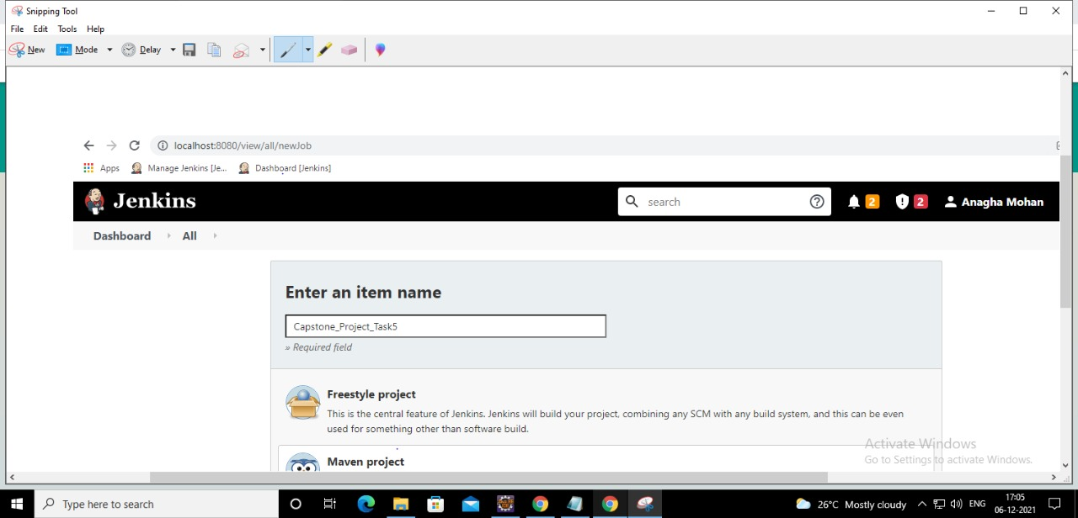

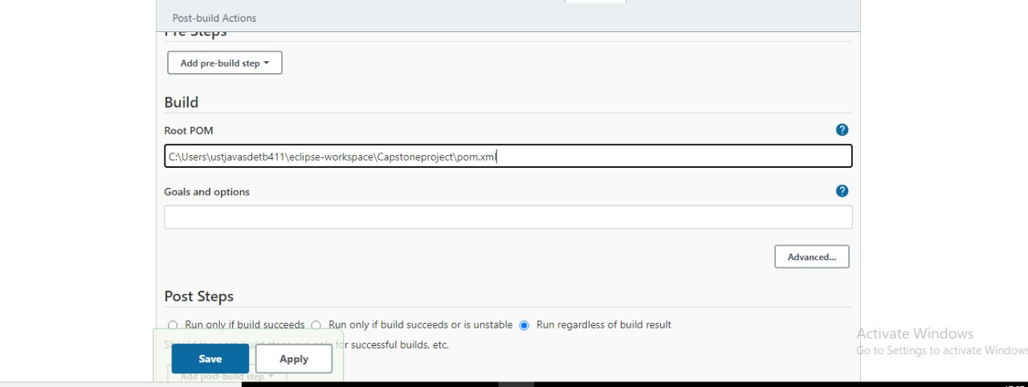

* Manage Jenkins 🡪 Global tool configuration 🡪 give the JDK path 🡪Then add maven and give its path also (path of that apache-maven-3.3.1 zip file) 🡪 Then save & apply

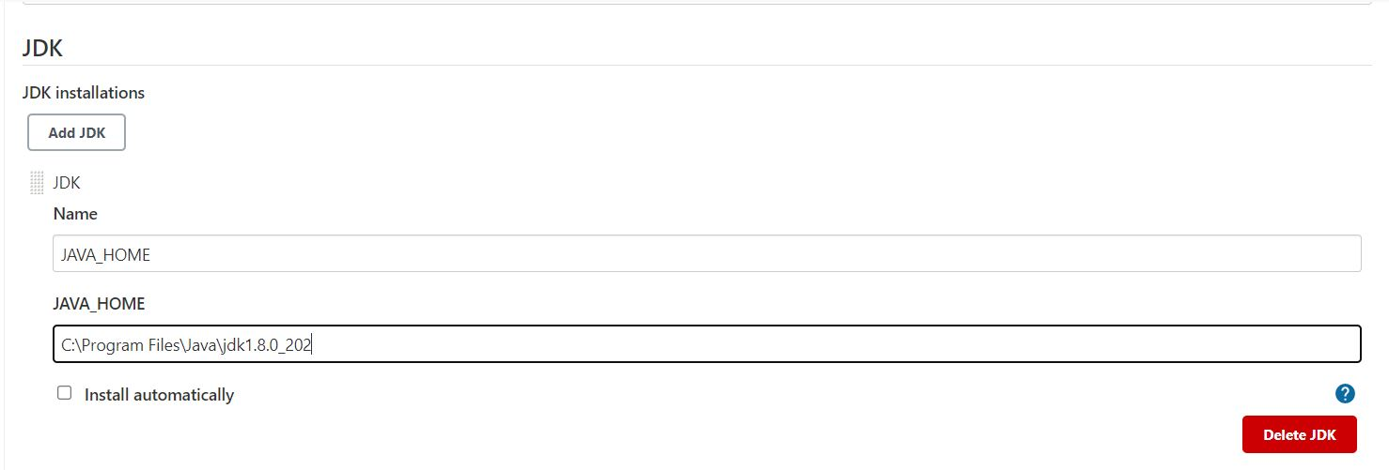

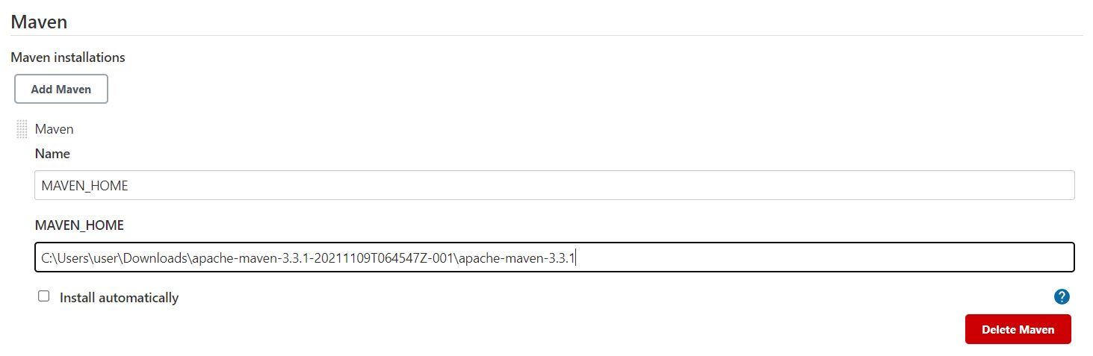

* Select the project 🡪 click Build now 🡪 click on the #1 🡪 then click Console output

